Worship at Home: 7/11/2020
Sixth Sunday after Pentecost

GATHERING

CONFESSION AND FORGIVENESS
In the name of the Father,
and of the ☩ Son,
and of the Holy Spirit.
Amen.

Almighty God, to whom all hearts are open, all desires known, and from whom no secrets are hid: cleanse the thoughts of our hearts by the inspiration of your Holy Spirit, that we may perfectly love you and worthily magnify your holy name, through Jesus Christ our Lord.
Amen.

Let us confess our sin in the presence of God and of one another.
Most merciful God,
we confess that we are captive to sin and cannot free ourselves. We have sinned against you in thought, word, and deed, by what we have done and by what we have left undone. We have not loved you with our whole heart; we have not loved our neighbors as ourselves. For the sake of your Son, Jesus Christ, have mercy on us. Forgive us, renew us, and lead us, so that we may delight in your will and walk in your ways, to the glory of your holy name.
Amen.

In the mercy of almighty God, Jesus Christ was given to die for us, and for his sake God forgives us all our sins. As a called and ordained minister of the church of Christ, and by his authority, I therefore declare to you the entire forgiveness of all your sins, in the name of the Father, and of the ☩ Son, and of the Holy Spirit.
Amen.

GATHERING SONG Light Dawns on a Weary World (ELW 726)
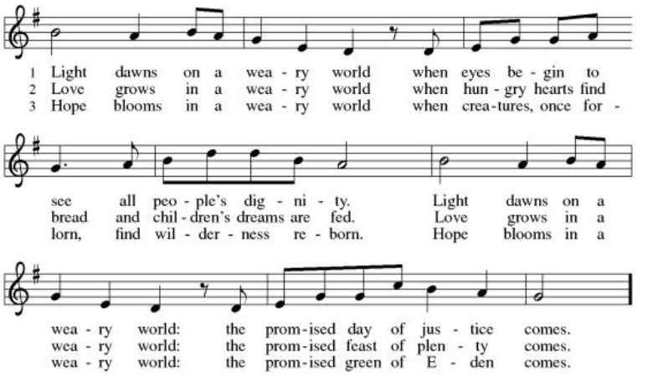
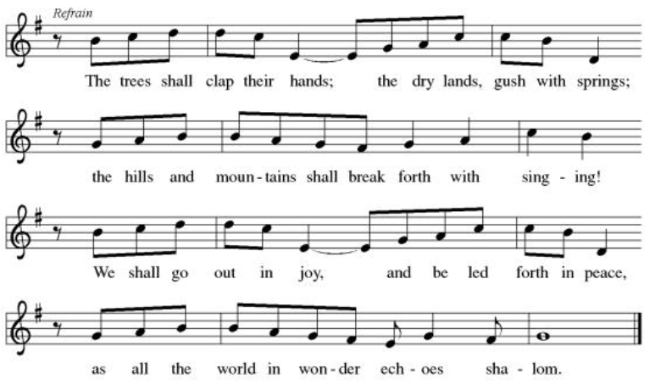

GREETING
The grace of our Lord Jesus Christ, the love of God,
and the communion of the Holy Spirit be with you all.
And also with you.

PRAYER OF THE DAY
Let us pray.
Almighty God, we thank you for planting in us the seed of your word. By your Holy Spirit help us to receive it with joy, live according to it, and grow in faith and hope and love, through Jesus Christ, our Savior and Lord. Amen.

WORD

FIRST READING: Isaiah 55:10-13

¹⁰For as the rain and the snow come down from heaven,
and do not return there until they have watered the earth,
making it bring forth and sprout,
giving seed to the sower and bread to the eater,
¹¹so shall my word be that goes out from my mouth;
it shall not return to me empty,
but it shall accomplish that which I purpose,
and succeed in the thing for which I sent it.
¹²For you shall go out in joy,
and be led back in peace;
the mountains and the hills before you
shall burst into song,
and all the trees of the field shall clap their hands.
¹³Instead of the thorn shall come up the cypress;
instead of the brier shall come up the myrtle;
and it shall be to the Lord for a memorial,
for an everlasting sign that shall not be cut off.

The word of the Lord.
Thanks be to God.

PSALM: Psalm 65:9-13
⁹You visit the earth and water it abundantly; you make it very plenteous; the river of God is | full of water.
You prepare the grain, for so you provide | for the earth.
¹⁰You drench the furrows and smooth | out the ridges;
with heavy rain you soften the ground and | bless its increase.
¹¹You crown the year | with your goodness,
and your paths over- | flow with plenty.
¹²May the fields of the wilderness be | rich for grazing,
and the hills be | clothed with joy.
¹³May the meadows cover themselves with flocks, and the valleys cloak them- | selves with grain;
let them shout for | joy and sing.

SECOND READING: Romans 8:1-11

¹There is therefore now no condemnation for those who are in Christ Jesus. ²For the law of the Spirit of life in Christ Jesus has set you free from the law of sin and of death. ³For God has done what the law, weakened by the flesh, could not do: by sending his own Son in the likeness of sinful flesh, and to deal with sin, he condemned sin in the flesh, ⁴so that the just requirement of the law might be fulfilled in us, who walk not according to the flesh but according to the Spirit. ⁵For those who live according to the flesh set their minds on the things of the flesh, but those who live according to the Spirit set their minds on the things of the Spirit. ⁶To set the mind on the flesh is death, but to set the mind on the Spirit is life and peace. ⁷For this reason the mind that is set on the flesh is hostile to God; it does not submit to God’s law—indeed it cannot, ⁸and those who are in the flesh cannot please God.
⁹But you are not in the flesh; you are in the Spirit, since the Spirit of God dwells in you. Anyone who does not have the Spirit of Christ does not belong to him. ¹⁰But if Christ is in you, though the body is dead because of sin, the Spirit is life because of righteousness. ¹¹If the Spirit of him who raised Jesus from the dead dwells in you, he who raised Christ from the dead will give life to your mortal bodies also through his Spirit that dwells in you.

The word of the Lord.
Thanks be to God.

GOSPEL: Matthew 13:1-9, 18-23

The holy gospel according to Matthew.
Glory to you, O Lord.

¹That same day Jesus went out of the house and sat beside the sea. ²Such great crowds gathered around him that he got into a boat and sat there, while the whole crowd stood on the beach. ³And he told them many things in parables, saying: “Listen! A sower went out to sow. ⁴And as he sowed, some seeds fell on the path, and the birds came and ate them up. ⁵Other seeds fell on rocky ground, where they did not have much soil, and they sprang up quickly, since they had no depth of soil. ⁶But when the sun rose, they were scorched; and since they had no root, they withered away. ⁷Other seeds fell among thorns, and the thorns grew up and choked them. ⁸Other seeds fell on good soil and brought forth grain, some a hundredfold, some sixty, some thirty. ⁹Let anyone with ears listen!”
¹⁸“Hear then the parable of the sower. ¹⁹When anyone hears the word of the kingdom and does not understand it, the evil one comes and snatches away what is sown in the heart; this is what was sown on the path. ²⁰As for what was sown on rocky ground, this is the one who hears the word and immediately receives it with joy; ²¹yet such a person has no root, but endures only for a while, and when trouble or persecution arises on account of the word, that person immediately falls away. ²²As for what was sown among thorns, this is the one who hears the word, but the cares of the world and the lure of wealth choke the word, and it yields nothing. ²³But as for what was sown on good soil, this is the one who hears the word and understands it, who indeed bears fruit and yields, in one case a hundredfold, in another sixty, and in another thirty.”

The gospel of the Lord.
Praise to you, O Christ.

SERMON

HYMN OF THE DAY Lord, Let My Heart be Good Soil (ELW 512)

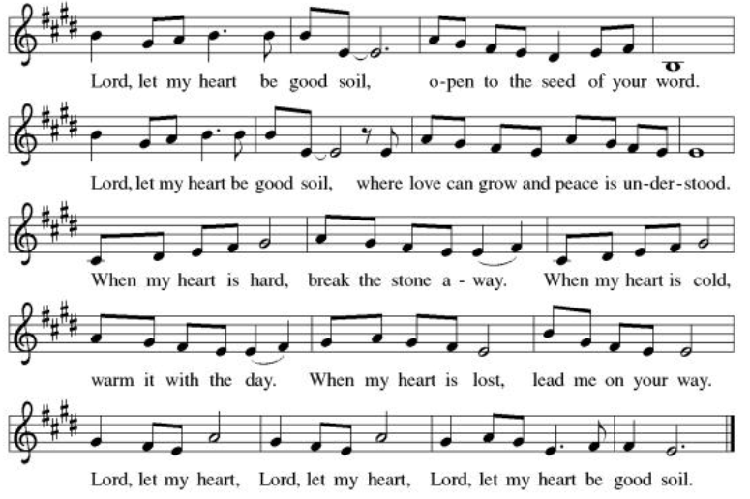

CREED
I believe in God, the Father almighty,
creator of heaven and earth.
I believe in Jesus Christ, God’s only Son, our Lord,
who was conceived by the Holy Spirit,
born of the virgin Mary,
suffered under Pontius Pilate,
was crucified, died, and was buried;
he descended to the dead.*
On the third day he rose again;
he ascended into heaven,
he is seated at the right hand of the Father,
and he will come to judge the living and the dead.
I believe in the Holy Spirit,
the holy catholic church,
the communion of saints,
the forgiveness of sins,
the resurrection of the body,
and the life everlasting. Amen.

PRAYERS OF INTERCESSION
Pr. Bill Wendt – Former pastor of Pleasant Valley. Healing after surgery.
Maureen Kuhn — Kay’s sister-in-law. Starting treatment this week.
Kirk Hove – Margaret Hazen’s grandson. Healing.
Kitty Ferrara – Kari’s Aunt. Preparing for 2 heart surgeries
Deb Friis - treatment for cancer, friend of the Vlcek’s
Riverlyn Walsh – an infant grandniece of Jennifer and Eric Anderson- has
leukemia, is receiving chemo treatments, has been having some bad days.
Catherine Erickson – pancreatic cancer
Gerri Sessions – strengthening & healing
Martha McCourt – Marianna Gilbertson’s mother. Living in a nursing home
with dementia
Henry Karnatz – Kari’s dad. Living with dementia
Holly Poore – in Thailand for 1 year, teaching English
Dan and Shelby Hill and family - missionaries living in France
Keyla Lisbeth - the Sharing the Dream recipient, student in Guatemala
Our service men and women; Alex Bauer stationed in South Korea
The inmates at CVCTF The neighborhood people we have chosen to pray for
this month.
Those in our community for whom we pray this month

All those on our visiting list:
Bob Dutter, Gary and Sharon Hazen,
Jim and Janice Teigen
All those on our visiting list:
Bob Dutter, Gary and Sharon Hazen,
Jim and Janice Teigen

PEACE
The peace of the Lord be with you all.
And also with you.

OFFERING

Please mail your offering to either:

Pleasant Valley Lutheran Church
W2450 Cty Rd WW
Eleva WI 54738.

Roxie Ulness
W3044 Pine Rd.
Eleva WI 54738

THANKSGIVING FOR THE WORD
Let us pray.
Praise and thanks to you, holy God, for by your Word you made all things: you spoke light into darkness, called forth beauty from chaos, and brought life into being. For your Word of life, O God,
we give you thanks and praise.
By your Word you called your people Israel to tell of your wonderful gifts: freedom from captivity, water on the desert journey, a pathway home from exile, wisdom for life with you. For your Word of life, O God,
we give you thanks and praise.
Through Jesus, your Word made flesh, you speak to us and call us to witness: forgiveness through the cross, life to those entombed by death, the way of your self-giving love. For your Word of life, O God,
we give you thanks and praise.
Send your Spirit of truth, O God; rekindle your gifts within us: renew our faith, increase our hope, and deepen our love, for the sake of a world in need. Faithful to your Word, O God, draw near to all who call on you; through Jesus Christ, our Savior and Lord, to whom, with you and the Holy Spirit, be honor and glory forever.
Amen.

LORD’S PRAYER
Gathered into one by the Holy Spirit, let us pray as Jesus taught us.
Our Father, who art in heaven,
hallowed be thy name,
thy kingdom come,
thy will be done,
on earth as it is in heaven.
Give us this day our daily bread;
and forgive us our trespasses,
as we forgive those
who trespass against us;
and lead us not into temptation,
but deliver us from evil.
For thine is the kingdom,
and the power, and the glory,
forever and ever. Amen.

SENDING

BLESSING
The Lord bless you and keep you.
The Lord make his face face shine on you and be gracious to you.
The Lord look upon you with favor and ☩ give you peace.
Amen.

SENDING SONG Sent Forth by God’s Blessing (ELW 547)
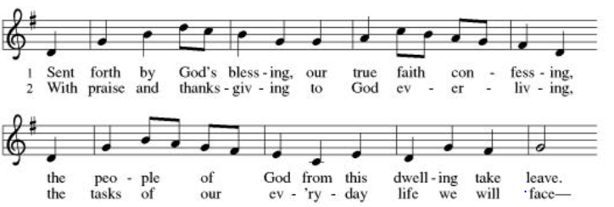
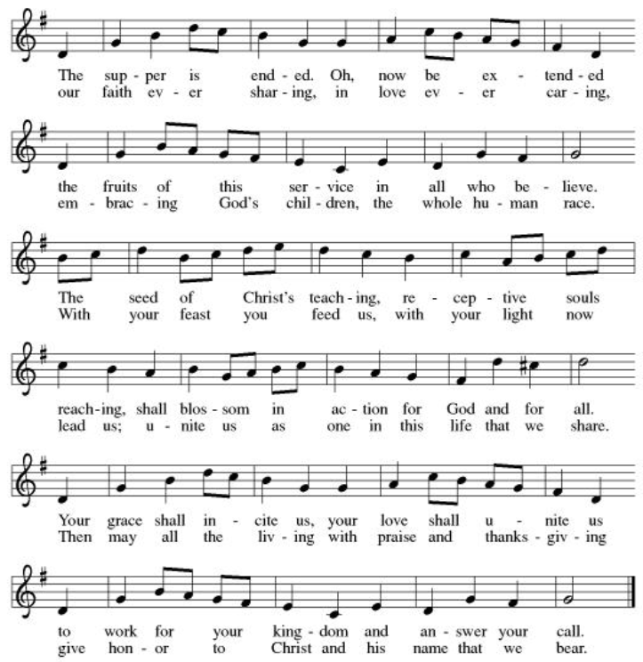

DISMISSAL
Go in peace. Serve the Lord.
Thanks be to God.

