Worship at Home: 5/24/2020
Resurrection Sunday

GATHERING

THANKSGIVING FOR BAPTISM
Blessed be the holy Trinity, ☩ one God,
the fountain of living water,
the rock who gave us birth
our light and our salvation.
Amen.

Joined to Christ in the waters of baptism, we are clothed with God's mercy and forgiveness. Let us give thanks for the gift of baptism.

We give you thanks, O God, for in the beginning your Spirit moved over the waters and by your Word you created the world, calling forth life in which you took delight.

Through the waters of the flood you delivered Noah and his family. Through the sea you led your people Israel from slavery into freedom. At the river your Son was baptized by John and anointed with the Holy Spirit.

By water and your Word you claim us as daughters and sons, making us heirs of your promise and servants of all.

We praise you for the gift of water that sustains life, and above all we praise you for the gift of new life in Jesus Christ.

Shower us with your Spirit, and renew our lives with your forgiveness, grace, and love.
To you be given honor and praise through Jesus Christ our Lord in the unity of the Holy Spirit, now and forever.
Amen.

GATHERING SONG
In Christ Alone, Sung by Mariah Sands

GREETING
The grace of our Lord Jesus Christ, the love of God,
and the communion of the Holy Spirit be with you all.
And also with you.

KYRIE (ELW p. 184)
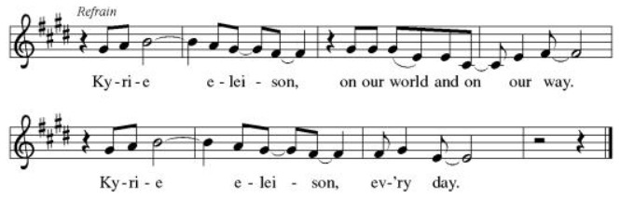
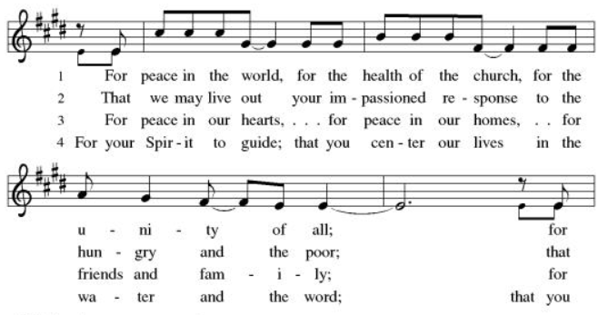
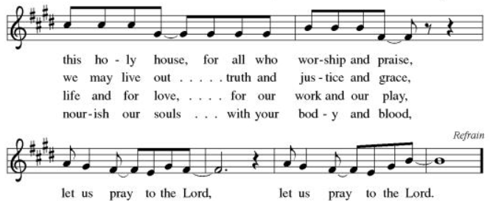

CANTICLE OF PRAISE (ELW p. 185)
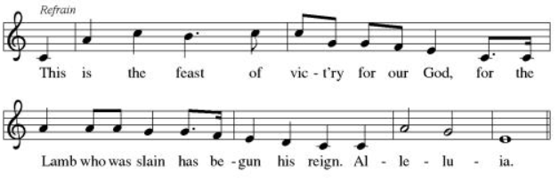
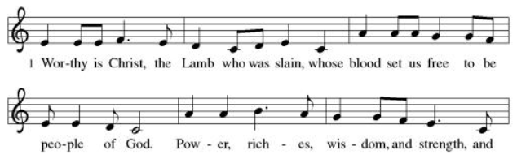
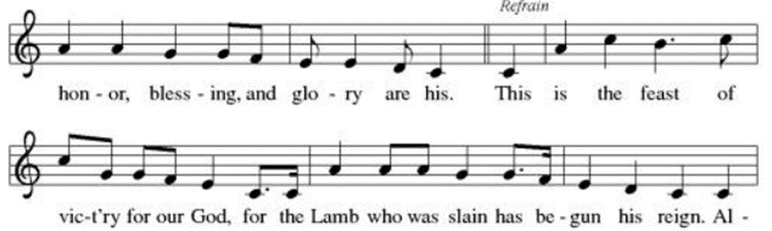
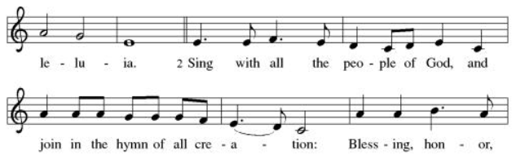
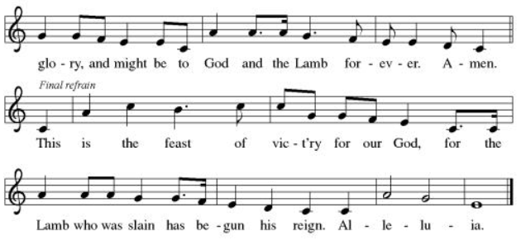

PRAYER OF THE DAY
Let us pray.
Almighty God, your only Son was taken into heaven and in your presence intercedes for us. Receive us and our prayers for all the world, and in the end bring everything into your glory, through Jesus Christ, our Sovereign and Lord, who lives and reigns with you and the Holy Spirit, one God, now and forever. Amen.

WORD

FIRST READING: Acts 1:1-11
A reading from Acts.

In the first book, Theophilus, I wrote about all that Jesus did and taught from the beginning 2 until the day when he was taken up to heaven, after giving instructions through the Holy Spirit to the apostles whom he had chosen. 3 After his suffering he presented himself alive to them by many convincing proofs, appearing to them during forty days and speaking about the kingdom of God. 4 While staying[a] with them, he ordered them not to leave Jerusalem, but to wait there for the promise of the Father. “This,” he said, “is what you have heard from me; 5 for John baptized with water, but you will be baptized with[b] the Holy Spirit not many days from now.”

6 So when they had come together, they asked him, “Lord, is this the time when you will restore the kingdom to Israel?” 7 He replied, “It is not for you to know the times or periods that the Father has set by his own authority. 8 But you will receive power when the Holy Spirit has come upon you; and you will be my witnesses in Jerusalem, in all Judea and Samaria, and to the ends of the earth.” 9 When he had said this, as they were watching, he was lifted up, and a cloud took him out of their sight. 10 While he was going and they were gazing up toward heaven, suddenly two men in white robes stood by them. 11 They said, “Men of Galilee, why do you stand looking up toward heaven? This Jesus, who has been taken up from you into heaven, will come in the same way as you saw him go into heaven.”

The word of the Lord.
Thanks be to God.

PSALM: Psalm 47

Clap your hands, all you peoples;
shout to God with loud songs of joy.
For the LORD, the Most High, is awesome,
a great king over all the earth.
He subdued peoples under us,
and nations under our feet.
He chose our heritage for us,
the pride of Jacob whom he loves.
God has gone up with a shout,
the LORD with the sound of a trumpet.
Sing praises to God, sing praises;
sing praises to our King, sing praises.
For God is the king of all the earth;
sing praises with a psalm.
God is king over the nations;
God sits on his holy throne.
The princes of the peoples gather as the people of the God of Abraham.
For the shields of the earth belong to God; he is highly exalted.

SECOND READING: Ephesians 1:15-23
A reading from Ephesians

15 I have heard of your faith in the Lord Jesus and your love[a] toward all the saints, and for this reason 16 I do not cease to give thanks for you as I remember you in my prayers. 17 I pray that the God of our Lord Jesus Christ, the Father of glory, may give you a spirit of wisdom and revelation as you come to know him, 18 so that, with the eyes of your heart enlightened, you may know what is the hope to which he has called you, what are the riches of his glorious inheritance among the saints, 19 and what is the immeasurable greatness of his power for us who believe, according to the working of his great power. 20 God[b] put this power to work in Christ when he raised him from the dead and seated him at his right hand in the heavenly places, 21 far above all rule and authority and power and dominion, and above every name that is named, not only in this age but also in the age to come. 22 And he has put all things under his feet and has made him the head over all things for the church, 23 which is his body, the fullness of him who fills all in all.

The word of the Lord.
Thanks be to God.

GOSPEL: John 17:1-11

The holy gospel according to John.
Glory to you, O Lord.

1 After Jesus had spoken these words, he looked up to heaven and said, "Father, the hour has come; glorify your Son so that the Son may glorify you, 2 since you have given him authority over all people, to give eternal life to all whom you have given him. 3 And this is eternal life, that they may know you, the only true God, and Jesus Christ whom you have sent. 4 I glorified you on earth by finishing the work that you gave me to do. 5 So now, Father, glorify me in your own presence with the glory that I had in your presence before the world existed. 6 "I have made your name known to those whom you gave me from the world. They were yours, and you gave them to me, and they have kept your word. 7 Now they know that everything you have given me is from you; 8 for the words that you gave to me I have given to them, and they have received them and know in truth that I came from you; and they have believed that you sent me. 9 I am asking on their behalf; I am not asking on behalf of the world, but on behalf of those whom you gave me, because they are yours. 10 All mine are yours, and yours are mine; and I have been glorified in them. 11 And now I am no longer in the world, but they are in the world, and I am coming to you. Holy Father, protect them in your name that you have given me, so that they may be one, as we are one.

The gospel of the Lord.
Praise to you, O Christ.

SERMON
The Rev. Laurie Skow-Anderson, Bishop of the Northwest Synod of Wisconsin

HYMN OF THE DAY Shine, Jesus, Shine
Words are printed on the video.

CREED
I believe in God, the Father almighty,
creator of heaven and earth.
I believe in Jesus Christ, God’s only Son, our Lord,
who was conceived by the Holy Spirit,
born of the virgin Mary,
suffered under Pontius Pilate,
was crucified, died, and was buried;
he descended to the dead.*
On the third day he rose again;
he ascended into heaven,
he is seated at the right hand of the Father,
and he will come to judge the living and the dead.
I believe in the Holy Spirit,
the holy catholic church,
the communion of saints,
the forgiveness of sins,
the resurrection of the body,
and the life everlasting. Amen.

PRAYERS OF INTERCESSION

The family of Kim Johnson - Sadie's niece - passed away on May 20 from
lung cancer.
The family of Romaine Knutson – Family to JonPaul and Jessica. Died on May 22nd from cancer.
Deb Friis - treatment for cancer, friend of the Vlcek’s
Riverlyn Walsh – an infant grandniece of Jennifer and Eric Anderson- has
leukemia, is receiving chemo treatments, has been having some bad days.
Catherine Erickson – pancreatic cancer
Gerri Sessions – strengthening & healing
Marth McCourt – Marianna Gilbertson’s mother. Living in a nursing home
with dementia
Henry Karnatz – Kari’s dad. Living with dementia
Holly Poore – in Thailand for 1 year, teaching English
Dan and Shelby Hill and family - missionaries living in France
Keyla Lisbeth - the Sharing the Dream recipient, student in Guatemala
Our service men and women; Alex Bauer stationed in South Korea
The inmates at CVCTF The neighborhood people we have chosen to pray for
this month. (Prayer’s on May 31st)
All those on our visiting list:
Bob Dutter, Gary and Sharon Hazen,
Jim and Janice Teigen

PEACE
The peace of Christ be with you always.
And also with you.

OFFERING

Please mail your offering to either:

Pleasant Valley Lutheran Church
W2450 Cty Rd WW
Eleva WI 54738.

Roxie Ulness
W3044 Pine Rd.
Eleva WI 54738

THANKSGIVING FOR THE WORD
Let us pray.
Praise and thanks to you, holy God, for by your Word you made all things: you spoke light into darkness, called forth beauty from chaos, and brought life into being. For your Word of life, O God,
we give you thanks and praise.
By your Word you called your people Israel to tell of your wonderful gifts: freedom from captivity, water on the desert journey, a pathway home from exile, wisdom for life with you. For your Word of life, O God,
we give you thanks and praise.
Through Jesus, your Word made flesh, you speak to us and call us to witness: forgiveness through the cross, life to those entombed by death, the way of your self-giving love. For your Word of life, O God,
we give you thanks and praise.
Send your Spirit of truth, O God; rekindle your gifts within us: renew our faith, increase our hope, and deepen our love, for the sake of a world in need. Faithful to your Word, O God, draw near to all who call on you; through Jesus Christ, our Savior and Lord, to whom, with you and the Holy Spirit, be honor and glory forever.
Amen.

LORD’S PRAYER
Gathered into one by the Holy Spirit, let us pray as Jesus taught us.
Our Father, who art in heaven,
hallowed be thy name,
thy kingdom come,
thy will be done,
on earth as it is in heaven.
Give us this day our daily bread;
and forgive us our trespasses,
as we forgive those
who trespass against us;
and lead us not into temptation,
but deliver us from evil.
For thine is the kingdom,
and the power, and the glory,
forever and ever. Amen.

SENDING

ANNOUNCEMENTS

BLESSING
The Lord bless you and keep you.
The Lord’s face shine on you and be gracious to you.
The Lord look upon you with favor and ☩ give you peace.
Amen.

SENDING SONG
Ten Thousand Reasons, sung by Mariah Sands

DISMISSAL
Go in peace. Share the good news.
Thanks be to God.

