Worship at Home: 4/19/2020
Second Sunday of Easter

GATHERING

THANKSGIVING FOR BAPTISM
Blessed be the holy Trinity, ☩ one God,
the fountain of living water,
the rock who gave us birth,
our light and our salvation.
Amen.

Joined to Christ in the waters of baptism,
we are clothed with God's mercy and forgiveness.
Let us give thanks for the gift of baptism.
We give you thanks, O God,
for in the beginning your Spirit moved over the waters
and by your Word you created the world,
calling forth life in which you took delight.
Through the waters of the flood you delivered Noah and his family.
Through the sea you led your people Israel from slavery into freedom.
At the river your Son was baptized by John and anointed with the Holy Spirit.
By water and your Word you claim us as daughters and sons,
making us heirs of your promise and servants of all.
We praise you for the gift of water that sustains life,
and above all we praise you for the gift of new life in Jesus Christ.
Shower us with your Spirit,
and renew our lives with your forgiveness, grace, and love.
To you be given honor and praise
through Jesus Christ our Lord
in the unity of the Holy Spirit, now and forever.
Amen.

GATHERING SONG Christ the Lord Is Risen Today; Alleluia! (ELW 369)
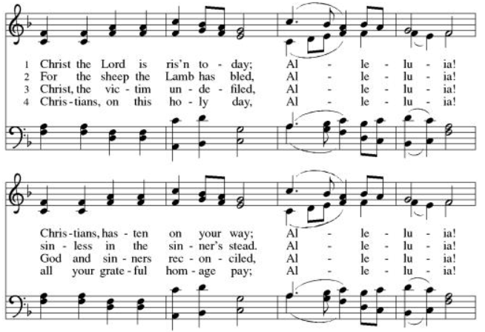
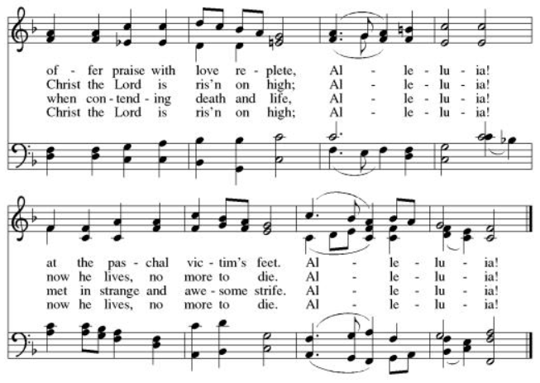

GREETING (ELW p. 184)
The grace of our Lord Jesus Christ, the love of God,
and the communion of the Holy Spirit be with you all.
And also with you.

KYRIE (ELW p. 184)

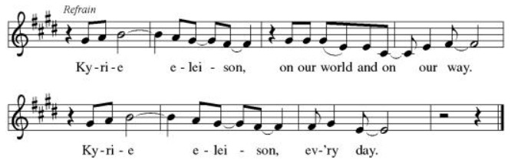
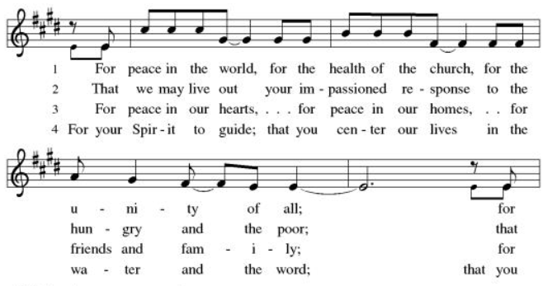
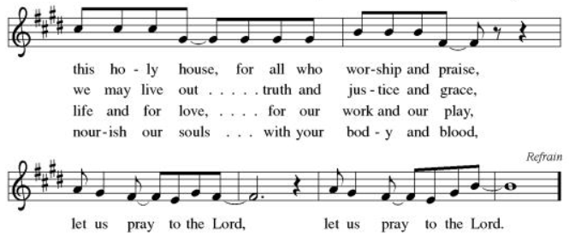

CANTICLE OF PRAISE (ELW p. 185)
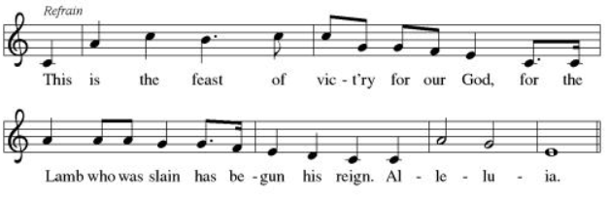
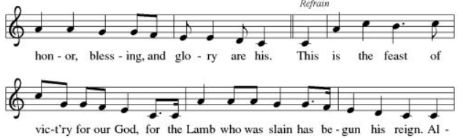
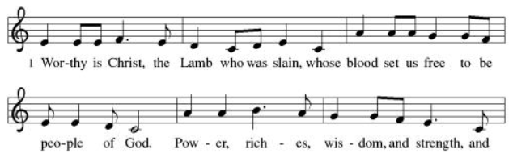

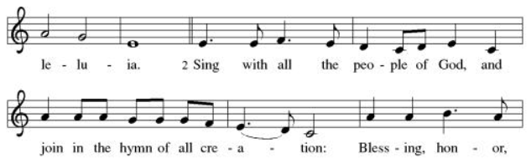
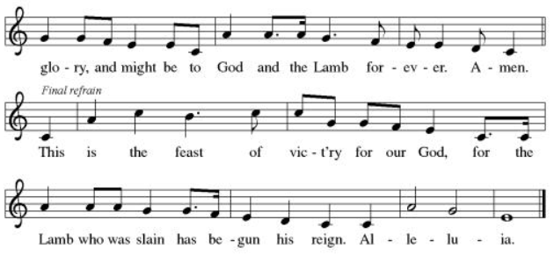

PRAYER OF THE DAY
Let us pray.
O God, your Son makes himself known to all his disciples in the breaking of bread. Open the eyes of our faith, that we may see him in his redeeming work, who lives and reigns with you and the Holy Spirit, one God, now and forever.
Amen.

WORD

FIRST READING: Acts 2:14a, 36-41
A reading from Acts.
^{14a}Peter, standing with the eleven, raised his voice and addressed [the crowd], ³⁶“Therefore let the entire house of Israel know with certainty that God has made him both Lord and Messiah, this Jesus whom you crucified.”
³⁷Now when they heard this, they were cut to the heart and said to Peter and to the other apostles, “Brothers, what should we do?” ³⁸Peter said to them, “Repent, and be baptized every one of you in the name of Jesus Christ so that your sins may be forgiven; and you will receive the gift of the Holy Spirit. ³⁹For the promise is for you, for your children, and for all who are far away, everyone whom the Lord our God calls to him.” ⁴⁰And he testified with many other arguments and exhorted them, saying, “Save yourselves from this corrupt generation.” ⁴¹So those who welcomed his message were baptized, and that day about three thousand persons were added.
The word of the Lord.
Thanks be to God.

PSALM: 116:1-4, 12-19
¹I love the Lord, who has | heard my voice,
and listened to my | supplication,
²for the Lord has given | ear to me
whenev- | er I called.
³The cords of death entangled me; the anguish of the grave | came upon me;
I came to | grief and sorrow.
⁴Then I called upon the name | of the Lord:
“O Lord, I pray you, | save my life.” R
¹²How shall I re- | pay the Lord
for all the good things God has | done for me?
¹³I will lift the cup | of salvation
and call on the name | of the Lord.
¹⁴I will fulfill my vows | to the Lord
in the presence of | all God’s people.
¹⁵Precious in your | sight, O Lord,
is the death | of your servants.
¹⁶O Lord, truly I | am your servant;
I am your servant, the child of your handmaid; you have freed me | from my bonds.
¹⁷I will offer you the sacrifice | of thanksgiving
and call upon the name | of the Lord. R
¹⁸I will fulfill my vows | to the Lord
in the presence of | all God’s people,
¹⁹in the courts of | the Lord‘s house,
in the midst of you, O Jerusalem. | Hallelujah!

SECOND READING: 1 Peter 1:17-23
A reading from 1 Peter.

¹⁷If you invoke as Father the one who judges all people impartially according to their deeds, live in reverent fear during the time of your exile. ¹⁸You know that you were ransomed from the futile ways inherited from your ancestors, not with perishable things like silver or gold, ¹⁹but with the precious blood of Christ, like that of a lamb without defect or blemish. ²⁰He was destined before the foundation of the world, but was revealed at the end of the ages for your sake. ²¹Through him you have come to trust in God, who raised him from the dead and gave him glory, so that your faith and hope are set on God.
²²Now that you have purified your souls by your obedience to the truth so that you have genuine mutual love, love one another deeply from the heart. ²³You have been born anew, not of perishable but of imperishable seed, through the living and enduring word of God.

The word of the Lord.
Thanks be to God.

GOSPEL: Luke 24:13-35
The holy gospel according to John.
Glory to you, O Lord.

¹³Now on that same day [when Jesus had appeared to Mary Magdalene,] two [disciples] were going to a village called Emmaus, about seven miles from Jerusalem, ¹⁴and talking with each other about all these things that had happened. ¹⁵While they were talking and discussing, Jesus himself came near and went with them, ¹⁶but their eyes were kept from recognizing him. ¹⁷And he said to them, “What are you discussing with each other while you walk along?” They stood still, looking sad. ¹⁸Then one of them, whose name was Cleopas, answered him, “Are you the only stranger in Jerusalem who does not know the things that have taken place there in these days?” ¹⁹He asked them, “What things?” They replied, “The things about Jesus of Nazareth, who was a prophet mighty in deed and word before God and all the people, ²⁰and how our chief priests and leaders handed him over to be condemned to death and crucified him. ²¹But we had hoped that he was the one to redeem Israel. Yes, and besides all this, it is now the third day since these things took place. ²²Moreover, some women of our group astounded us. They were at the tomb early this morning, ²³and when they did not find his body there, they came back and told us that they had indeed seen a vision of angels who said that he was alive. ²⁴Some of those who were with us went to the tomb and found it just as the women had said; but they did not see him.” ²⁵Then he said to them, “Oh, how foolish you are, and how slow of heart to believe all that the prophets have declared! ²⁶Was it not necessary that the Messiah should suffer these things and then enter into his glory?” ²⁷Then beginning with Moses and all the prophets, he interpreted to them the things about himself in all the scriptures.
²⁸As they came near the village to which they were going, he walked ahead as if he were going on. ²⁹But they urged him strongly, saying, “Stay with us, because it is almost evening and the day is now nearly over.” So he went in to stay with them. ³⁰When he was at the table with them, he took bread, blessed and broke it, and gave it to them. ³¹Then their eyes were opened, and they recognized him; and he vanished from their sight. ³²They said to each other, “Were not our hearts burning within us while he was talking to us on the road, while he was opening the scriptures to us?” ³³That same hour they got up and returned to Jerusalem; and they found the eleven and their companions gathered together. ³⁴They were saying, “The Lord has risen indeed, and he has appeared to Simon!” ³⁵Then they told what had happened on the road, and how he had been made known to them in the breaking of the bread.

The gospel of the Lord.
Praise to you, O Christ.

SERMON

HYMN OF THE DAY Bless Now, O God, the Journey (ELW 326)
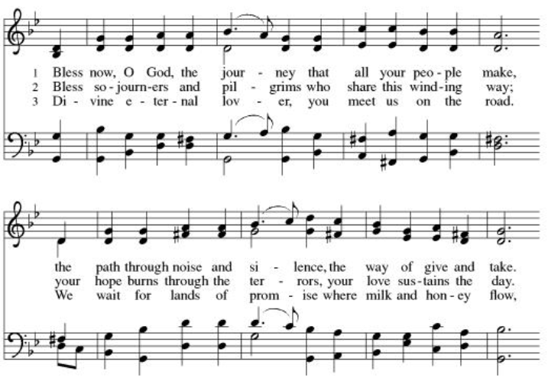
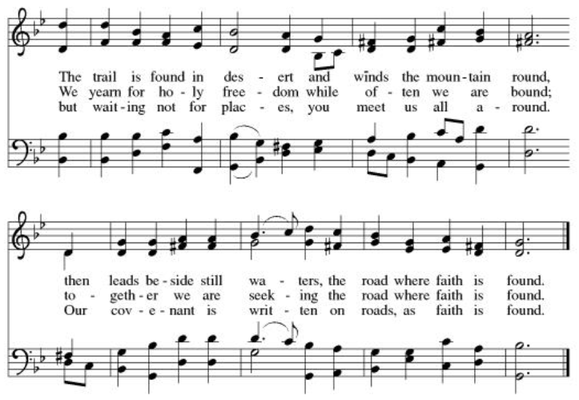

CREED
I believe in God, the Father almighty,
creator of heaven and earth.
I believe in Jesus Christ, God’s only Son, our Lord,
who was conceived by the Holy Spirit,
born of the virgin Mary,
suffered under Pontius Pilate,
was crucified, died, and was buried;
he descended to the dead.*
On the third day he rose again;
he ascended into heaven,
he is seated at the right hand of the Father,
and he will come to judge the living and the dead.
I believe in the Holy Spirit,
the holy catholic church,
the communion of saints,
the forgiveness of sins,
the resurrection of the body,
and the life everlasting. Amen.

PRAYERS OF INTERCESSION

For the Family of Willard Wilson – went home to be with the Lord on Palm Sunday at the age of 97
Bob Timm – recovering doing rehab at Dove
Deb Friis - treatment for cancer, friend of the Vlcek’s
Kim (neighbor to Pr. JonPaul and Jessica) - diagnosed with breast cancer
Riverlyn Walsh – a 2-month-old grandniece of Jennifer and Eric Anderson- has leukemia, is receiving chemo treatments.
Kim Johnson – Sadie’s niece - has been diagnosed with lung cancer.
Romaine Knutson – cancer; a member of Pastor’s family
Catherine Erickson – pancreatic cancer
Gerri Sessions – strengthening and healing
Holly Poore – in Thailand for 1 year, teaching English
Dan and Shelby Hill and family - missionaries living in France
Keyla Lisbeth - the Sharing the Dream recipient, student in Guatemala
Our service men and women; Alex Bauer stationed in South Korea
The inmates at CVCTF
The neighborhood people we have chosen to pray for this month.
(Prayer’s on May 31st)

All those on our visiting list:
Bob Dutter, Gary and Sharon Hazen,
Jim and Janice Teigen

PEACE
The Peace of the Lord be with you all
And also with you.

OFFERING
Please mail your offering to either:

Pleasant Valley Lutheran Church
W2450 Cty Rd WW
Eleva WI 54738.

Roxie Ulness
W3044 Pine Rd.
Eleva WI 54738

THANKSGIVING FOR THE WORD
Let us pray.
Praise and thanks to you, holy God, for by your Word you made all things: you spoke light into darkness, called forth beauty from chaos, and brought life into being. For your Word of life, O God,
we give you thanks and praise.
By your Word you called your people Israel to tell of your wonderful gifts: freedom from captivity, water on the desert journey, a pathway home from exile, wisdom for life with you. For your Word of life, O God,
we give you thanks and praise.
Through Jesus, your Word made flesh, you speak to us and call us to witness: forgiveness through the cross, life to those entombed by death, the way of your self-giving love. For your Word of life, O God,
we give you thanks and praise.
Send your Spirit of truth, O God; rekindle your gifts within us: renew our faith, increase our hope, and deepen our love, for the sake of a world in need. Faithful to your Word, O God, draw near to all who call on you; through Jesus Christ, our Savior and Lord, to whom, with you and the Holy Spirit, be honor and glory forever.
Amen.

LORD’S PRAYER
Gathered into one by the Holy Spirit, let us pray as Jesus taught us.
Our Father, who art in heaven,
hallowed be thy name,
thy kingdom come,
thy will be done,
on earth as it is in heaven.
Give us this day our daily bread;
and forgive us our trespasses,
as we forgive those
who trespass against us;
and lead us not into temptation,
but deliver us from evil.
For thine is the kingdom,
and the power, and the glory,
forever and ever. Amen.

SENDING
God blesses us and sends us in mission to the world.

ANNOUNCEMENTS

BLESSING
The Lord bless you and keep you.
The Lord’s face shine on you with grace and mercy.
The Lord look upon you with favor and ☩ give you peace.
Amen.

SENDING SONG Let All Things Now Living (ELW 881)
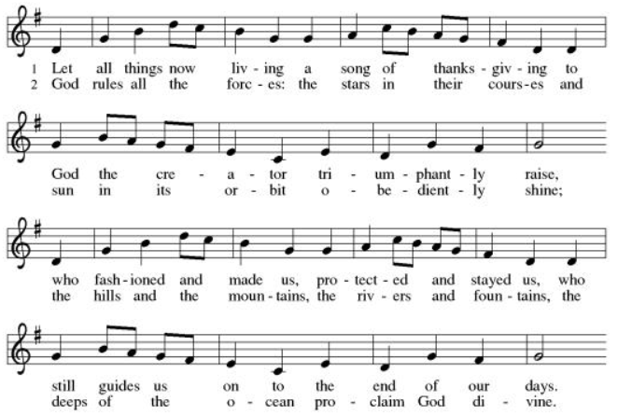
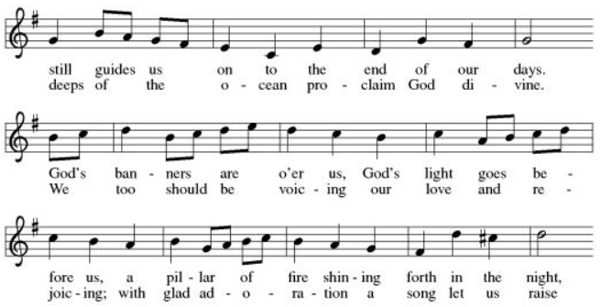
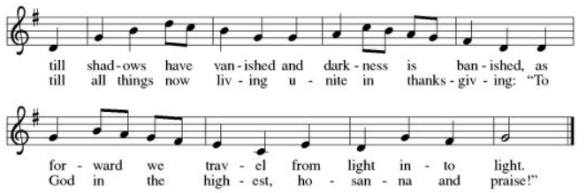

DISMISSAL (ELW p. 192)

Go in peace. Share the good news.
Thanks be to God.

