Worship at Home: 02/07/2021
5th Sunday after Epiphany

GATHERING

THANKSGIVING FOR BAPTISM (ELW p. 97)

Blessed be the holy Trinity, ☩ one God,
the fountain of living water,
the rock who gave us birth,
our light and our salvation.
Amen.

Joined to Christ in the waters of baptism,
we are clothed with God's mercy and forgiveness.
Let us give thanks for the gift of baptism.

We give you thanks, O God,
for in the beginning your Spirit moved over the waters
and by your Word you created the world,
calling forth life in which you took delight.
Through the waters of the flood you delivered Noah and his family.
Through the sea you led your people Israel from slavery into freedom.
At the river your Son was baptized by John and anointed with the Holy Spirit.
By water and your Word you claim us as daughters and sons,
making us heirs of your promise and servants of all.
We praise you for the gift of water that sustains life,
and above all we praise you for the gift of new life in Jesus Christ.
Shower us with your Spirit,
and renew our lives with your forgiveness, grace, and love.
To you be given honor and praise
through Jesus Christ our Lord
in the unity of the Holy Spirit, now and forever.
Amen.

GATHERING SONG Praise to the Lord, the Almighty (ELW 858)

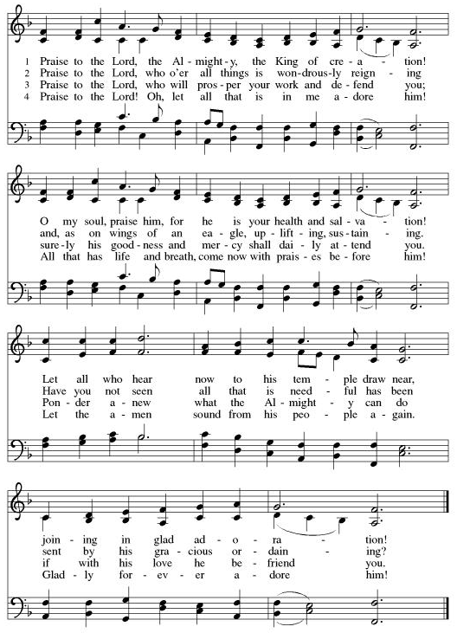

GREETING
The grace of our Lord Jesus Christ, the love of God,
and the communion of the Holy Spirit be with you all.
And also with you.

PRAYER OF THE DAY
Let us pray.
Everlasting God, you give strength to the weak and power to the faint. Make us agents of your healing and wholeness, that your good news may be made known to the ends of your creation, through Jesus Christ, our Savior and Lord. Amen.

WORD

FIRST READING: Isaiah 40:21-31
A reading from Isaiah.

21Have you not known? Have you not heard?
Has it not been told you from the beginning?
Have you not understood from the foundations of the earth?
22It is he who sits above the circle of the earth,
and its inhabitants are like grasshoppers;
who stretches out the heavens like a curtain,
and spreads them like a tent to live in;
23who brings princes to naught,
and makes the rulers of the earth as nothing.

24Scarcely are they planted, scarcely sown,
scarcely has their stem taken root in the earth,
when he blows upon them, and they wither,
and the tempest carries them off like stubble.

25To whom then will you compare me,
or who is my equal? says the Holy One.
26Lift up your eyes on high and see:
Who created these?
He who brings out their host and numbers them,
calling them all by name;
because he is great in strength,
mighty in power,
not one is missing.

27Why do you say, O Jacob,
and speak, O Israel,
“My way is hidden from the Lord,
and my right is disregarded by my God”?
28Have you not known? Have you not heard?
The Lord is the everlasting God,
the Creator of the ends of the earth.
He does not faint or grow weary;
his understanding is unsearchable.
29He gives power to the faint,
and strengthens the powerless.
30Even youths will faint and be weary,
and the young will fall exhausted;
31but those who wait for the Lord shall renew their strength,
they shall mount up with wings like eagles,
they shall run and not be weary,
they shall walk and not faint.

The word of the Lord.
Thanks be to God.

PSALM: Psalm 147:1-11, 20c

1Hallelujah! How good it is to sing praises | to our God!
How pleasant it is to honor | God with praise!
2The Lord re- | builds Jerusalem,
and gathers the ex- | iles of Israel.
3The Lord heals the | brokenhearted
and binds | up their wounds.
4The Lord counts the number | of the stars
and calls them all | by their names.
5Great is our Lord and might- | y in power;
there is no limit | to God’s wisdom.
6The Lord lifts | up the lowly,
but casts the wicked | to the ground.
7Sing to the Lord| with thanksgiving;
make music upon the harp | to our God,
8who covers the heav- | ens with clouds
and prepares rain for the earth, making grass to grow up- | on the mountains.
9God provides food | for the cattle
and for the young ravens | when they cry.
10God is not impressed by the might | of a horse,
and has no pleasure in the speed | of a runner,
11but finds pleasure in those who | fear the Lord,
in those who await God’s steadfast love. 20c| Hallelujah!

SECOND READING: 1 Corinthians 9:16-23
A reading from 1 Corinthians.

16If I proclaim the gospel, this gives me no ground for boasting, for an obligation is laid on me, and woe to me if I do not proclaim the gospel! 17For if I do this of my own will, I have a reward; but if not of my own will, I am entrusted with a commission. 18What then is my reward? Just this: that in my proclamation I may make the gospel free of charge, so as not to make full use of my rights in the gospel.
19For though I am free with respect to all, I have made myself a slave to all, so that I might win more of them. 20To the Jews I became as a Jew, in order to win Jews. To those under the law I became as one under the law (though I myself am not under the law) so that I might win those under the law. 21To those outside the law I became as one outside the law (though I am not free from God’s law but am under Christ’s law) so that I might win those outside the law. 22To the weak I became weak, so that I might win the weak. I have become all things to all people, that I might by all means save some. 23I do it all for the sake of the gospel, so that I may share in its blessings.

The word of the Lord.
Thanks be to God.

GOSPEL: Mark 1:29-39
The holy gospel according to Mark.
Glory to you, O Lord.

29As soon as [Jesus and the disciples] left the synagogue, they entered the house of Simon and Andrew, with James and John. 30Now Simon’s mother-in-law was in bed with a fever, and they told him about her at once. 31He came and took her by the hand and lifted her up. Then the fever left her, and she began to serve them.
32That evening, at sunset, they brought to him all who were sick or possessed with demons. 33And the whole city was gathered around the door. 34And he cured many who were sick with various diseases, and cast out many demons; and he would not permit the demons to speak, because they knew him.
35In the morning, while it was still very dark, he got up and went out to a deserted place, and there he prayed. 36And Simon and his companions hunted for him. 37When they found him, they said to him, “Everyone is searching for you.” 38He answered, “Let us go on to the neighboring towns, so that I may proclaim the message there also; for that is what I came out to do.” 39And he went throughout Galilee, proclaiming the message in their synagogues and casting out demons.

The gospel of the Lord.
Praise to you, O Christ.
SERMON

HYMN OF THE DAY Praise the One Who Breaks the Darkness (ELW 843)

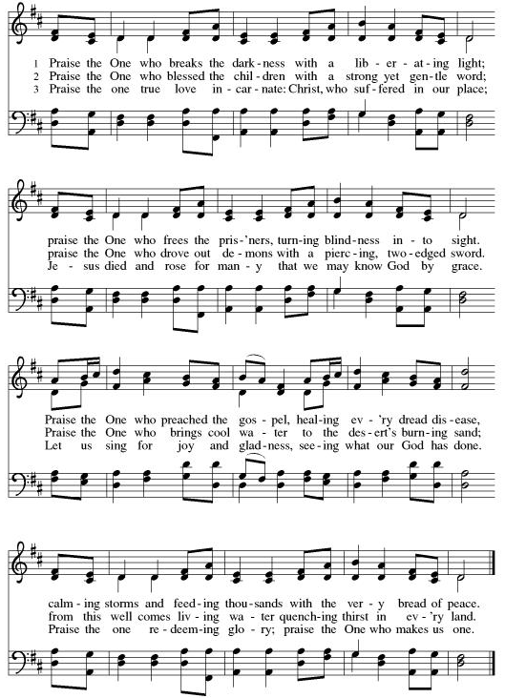

CREED
I believe in God, the Father almighty,
creator of heaven and earth.
I believe in Jesus Christ, God’s only Son, our Lord,
who was conceived by the Holy Spirit,
born of the virgin Mary,
suffered under Pontius Pilate,
was crucified, died, and was buried;
he descended to the dead.*
On the third day he rose again;
he ascended into heaven,
he is seated at the right hand of the Father,
and he will come to judge the living and the dead.
I believe in the Holy Spirit,
the holy catholic church,
the communion of saints,
the forgiveness of sins,
the resurrection of the body,
and the life everlasting. Amen.

PRAYERS OF INTERCESSION
The Family of Gerri Sessions – has passed away
The Family of Don Timm – passed away at his home, brother to Bob and sister to Sandy Schuch
Bob Timm – healing after knee replacement surgery this past week
Joan Timm – doing well at home (her name is pronounced JoAnn not Joan)
Marg Timm – Hospitalized with heart problem; both at Mayo
Troy Gilbertson - good test results in February
Dan Engum – complications with infectious diseases
Glen Klevgard– Thelma (Tweet - Goss); husband, in rehab at Mayo in Menomonie
Kari Karnatz - healing
Teresa Edison- fighting cancer, treatments are working – Monica’s cousin
Jan Murphy – healing from COVID, Sharon Anderson’s sister
Loris Anderson – Sharon’s Mom, healing
Gwen Chubb - Monica’s cousin. Done with treatments, upcoming Doc. app.to see if she is cancer free!
Maureen Kuhn — Kay’s sister-in-law, receiving stem cell transplant, at Rochester
Catherine Erickson – pancreatic cancer
Emily - Cathy Winger’s mom- living with dementia
Martha McCourt – Marianna’s mother, living with dementia
Henry Karnatz – Kari’s dad, living with dementia
Holly Poore –teaching English and Spanish in Thailand
Shelby Hill and family - missionaries living in France
Keyla Lisbeth - the Sharing the Dream recipient, student in Guatemala, we will be her sponsor for another yr.
All our service men and women:
Alex Bauer stationed in England
Brendan Poore - deployed to Somalia

All those on our visiting list:
Bob Dutter & Janice Teigen & Gary and Sharon Hazen

PEACE
The peace of the Lord be with you all.
And also with you.

OFFERING

Please mail your offering to either:

Pleasant Valley Lutheran Church
W2450 Cty Rd WW
Eleva WI 54738.

Roxie Ulness
W3044 Pine Rd.
Eleva WI 54738

OFFERING PRAYER
Let us pray.
Blessed are you, O God, maker of all things. Through your goodness you have blessed us with these gifts: our selves, our time, and our possessions. Use us, and what we have gathered, in feeding the world with your love, through the one who gave himself for us, Jesus Christ, our Savior and Lord. Amen.

THANKSGIVING FOR THE WORD
Let us pray.
Praise and thanks to you, holy God, for by your Word you made all things: you spoke light into darkness, called forth beauty from chaos, and brought life into being. For your Word of life, O God,
we give you thanks and praise.
By your Word you called your people Israel to tell of your wonderful gifts: freedom from captivity, water on the desert journey, a pathway home from exile, wisdom for life with you. For your Word of life, O God,
we give you thanks and praise.
Through Jesus, your Word made flesh, you speak to us and call us to witness: forgiveness through the cross, life to those entombed by death, the way of your self-giving love. For your Word of life, O God,
we give you thanks and praise.
Send your Spirit of truth, O God; rekindle your gifts within us: renew our faith, increase our hope, and deepen our love, for the sake of a world in need. Faithful to your Word, O God, draw near to all who call on you; through Jesus Christ, our Savior and Lord, to whom, with you and the Holy Spirit, be honor and glory forever.
Amen.

LORD’S PRAYER
Gathered into one by the Holy Spirit, let us pray as Jesus taught us.
Our Father, who art in heaven,
hallowed be thy name,
thy kingdom come,
thy will be done,
on earth as it is in heaven.
Give us this day our daily bread;
and forgive us our trespasses,
as we forgive those
who trespass against us;
and lead us not into temptation,
but deliver us from evil.
For thine is the kingdom,
and the power, and the glory,
forever and ever. Amen.

SENDING

BLESSING
The Lord bless you and keep you.
The Lord make his face face shine on you and be gracious to you.
The Lord look upon you with favor and ☩ give you peace.
Amen.

SENDING SONG Arise, Your Light Has Come! (ELW 314)

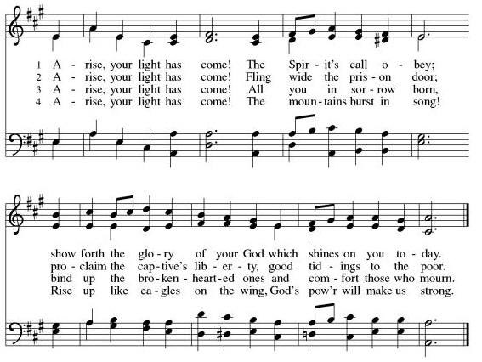

DISMISSAL
Go in peace. Serve the Lord.
Thanks be to God.

