Worship at Home: 4/5/2020
Palm Sunday

Gathering

Acclamation
Blessed is the one who comes in the name of the Lord.
Hosanna in the highest.

Blessing of Palms
The Lord be with you.
And also with you.

Let us pray.
We praise you, O God,
for redeeming the world through our Savior Jesus Christ.
Today he entered the holy city in triumph
and was proclaimed messiah and king
by those who spread garments and branches along his way.
Bless our branches and bless all those who carry them.
We gather from near and far, across digital time and space,
But together proclaim you kingship
Grant us grace to follow our Lord in the way of the cross,
so that, joined to his death and resurrection,
we enter into life with you;
through the same Jesus Christ,
who lives and reigns with you and the Holy Spirit,
one God, now and forever.
Amen.

Procession All Glory, Laud, and Honor (ELW 344)
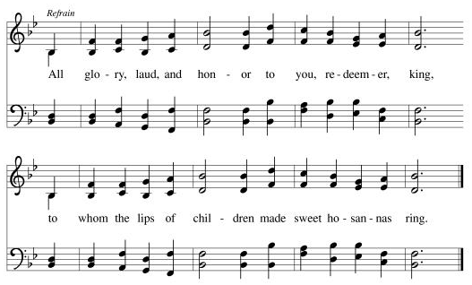
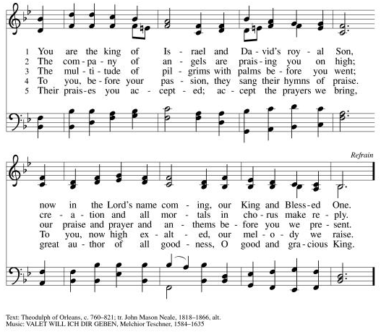

Prayer of the Day
As we now enter into the contemplation of the passion of our Lord Jesus Christ and meditate on the salvation of the world through his sufferings, death, burial, and resurrection, let us pray. Everlasting God, in your endless love for the human race you sent our Lord Jesus Christ to take on our nature and to suffer death on the cross. In your mercy enable us to share in his obedience to your will and in the glorious victory of his resurrection, who lives and reigns with you and the Holy Spirit, one God, now and forever.
Amen.

Word

First Reading: Isaiah 50:4-9a
A reading from Isaiah.
⁴The Lord God has given me
the tongue of a teacher,
that I may know how to sustain
the weary with a word.
Morning by morning he wakens—
wakens my ear
to listen as those who are taught.
⁵The Lord God has opened my ear,
and I was not rebellious,
I did not turn backward.
⁶I gave my back to those who struck me,
and my cheeks to those who pulled out the beard;
I did not hide my face
from insult and spitting.
⁷The Lord God helps me;
therefore I have not been disgraced;
therefore I have set my face like flint,
and I know that I shall not be put to shame;
⁸he who vindicates me is near.
Who will contend with me?
Let us stand up together.
Who are my adversaries?
Let them confront me.
^{9a}It is the Lord God who helps me;
who will declare me guilty?

The word of the Lord.
Thanks be to God.

Psalm: Psalm 31:9-16
⁹Have mercy on me, O Lord, for I | am in trouble;
my eye is consumed with sorrow, and also my throat | and my belly.
¹⁰For my life is wasted with grief, and my | years with sighing;
my strength fails me because of affliction, and my bones | are consumed.
¹¹I am the scorn of all my enemies, a disgrace to my neighbors, a dismay to | my acquaintances;
when they see me in the street | they avoid me.
¹²Like the dead I am forgotten, | out of mind;
I am as useless as a | broken pot. R
¹³For I have heard the whispering of the crowd; fear is | all around;
they put their heads together against me; they plot to | take my life.
¹⁴But as for me, I have trusted in | you, O Lord.
I have said, “You | are my God.
¹⁵My times are | in your hand;
rescue me from the hand of my enemies, and from those who | persecute me.
¹⁶Let your face shine up- | on your servant;
save me in your | steadfast love.” R

Second Reading: Philippians 2:5-11
A reading from Philippians.
⁵Let the same mind be in you that was in Christ Jesus,
⁶who, though he was in the form of God,
did not regard equality with God
as something to be exploited,
⁷but emptied himself,
taking the form of a slave,
being born in human likeness.
And being found in human form,
⁸he humbled himself
and became obedient to the point of death—
even death on a cross.
⁹Therefore God also highly exalted him
and gave him the name
that is above every name,
¹⁰so that at the name of Jesus
every knee should bend,
in heaven and on earth and under the earth,
¹¹and every tongue should confess
that Jesus Christ is Lord,
to the glory of God the Father.

The word of the Lord.
Thanks be to God.

Gospel: Matthew 21:1-11
The holy gospel according to Matthew.
Glory to you, O Lord.

¹When they had come near Jerusalem and had reached Bethphage, at the Mount of Olives, Jesus sent two disciples, ²saying to them, "Go into the village ahead of you, and immediately you will find a donkey tied, and a colt with her; untie them and bring them to me. ³If anyone says anything to you, just say this, 'The Lord needs them.' And he will send them immediately." ⁴This took place to fulfill what had been spoken through the prophet, saying,
⁵"Tell the daughter of Zion,
Look, your king is coming to you,
humble, and mounted on a donkey,
and on a colt, the foal of a donkey."
⁶The disciples went and did as Jesus had directed them; ⁷they brought the donkey and the colt, and put their cloaks on them, and he sat on them. ⁸A very large crowd spread their cloaks on the road, and others cut branches from the trees and spread them on the road. ⁹The crowds that went ahead of him and that followed were shouting,
"Hosanna to the Son of David!
Blessed is the one who comes in the name of the Lord!
Hosanna in the highest heaven!"
¹⁰When he entered Jerusalem, the whole city was in turmoil, asking, "Who is this?" ¹¹The crowds were saying, "This is the prophet Jesus from Nazareth in Galilee."

The gospel of the Lord.
Praise to you, O Christ.

Sermon

Hymn of the Day Prepare the Royal Highway (ELW 264)
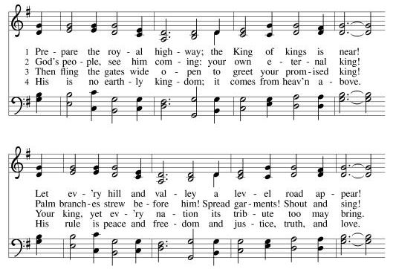
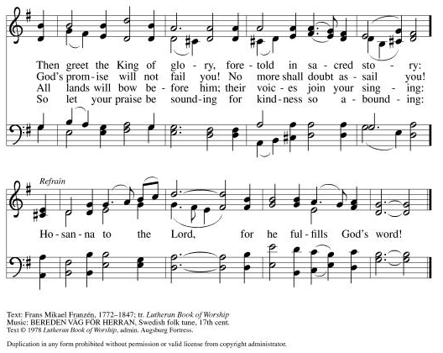

Creed
I believe in God, the Father almighty,
creator of heaven and earth.
I believe in Jesus Christ, God’s only Son, our Lord,
who was conceived by the Holy Spirit,
born of the virgin Mary,
suffered under Pontius Pilate,
was crucified, died, and was buried;
he descended to the dead.*
On the third day he rose again;
he ascended into heaven,
he is seated at the right hand of the Father,
and he will come to judge the living and the dead.
I believe in the Holy Spirit,
the holy catholic church,
the communion of saints,
the forgiveness of sins,
the resurrection of the body,
and the life everlasting. Amen.

*Or, “he descended into hell,” another translation of this text in widespread use.

Prayers of Intercession
Larry Sands – healing after surgery
Dave – Cathy Winger’s brother – reaching the end of his life
Bob and Nancy – healing; friends of Kari Karnatz’s
Rex Hand – his cancer has returned; friend of the Berger’s
Cheryl Sikorski – healing from brain surgery; friend of Monica’s
Jade Wampole - Randy and Joann’s 4 yr. old granddaughter diagnosed with Leukemia; is responding well to treatment
Kim (neighbor to Pr. JonPaul and Jessica) - diagnosed with breast cancer
Riverlyn Walsh – a 2-month-old grandniece of Jennifer and Eric Anderson- has leukemia, is receiving chemo treatments.
Kim Johnson - Sadie's niece - has been diagnosed with lung cancer.
Romaine Knutson – cancer; a member of Pastor’s family
Catherine Erickson – pancreatic cancer
Henry Karnatz – Kari‘s dad- suffering with dementia
Gerri Sessions – strengthening & healing
Holly Poore – in Thailand for 1 year, teaching English
Keyla Lisbeth - the Sharing the Dream recipient, student in Guatemala
Dan and Shelby Hill and family - missionaries living in France
Our service men and women; Alex Bauer stationed in South Korea
Healing for those afflicted from this corno19 virus
The inmates at CVCTF
The neighborhood people we have chosen to pray for this month

Peace
The peace of Christ be with you always.
And also with you.

Offering
Please mail your offering to either:

Pleasant Valley Lutheran Church
W2450 Cty Rd WW
Eleva WI 54738.

Roxie Ulness
W3044 Pine Rd.
Eleva WI 54738

Lord’s Prayer
Gathered into one by the Holy Spirit, let us pray as Jesus taught us.
Our Father, who art in heaven,
hallowed be thy name,
thy kingdom come,
thy will be done,
on earth as it is in heaven.
Give us this day our daily bread;
and forgive us our trespasses,
as we forgive those
who trespass against us;
and lead us not into temptation,
but deliver us from evil.
For thine is the kingdom,
and the power, and the glory,
forever and ever. Amen.

Sending
God blesses us and sends us in mission to the world.

Announcements

Blessing
The Lord bless you and keep you.
The Lord’s face shine on you and be gracious to you.
The Lord look upon you with favor and ☩ give you peace.
Amen.

Sending Song On Our Way Rejoicing (ELW 537)
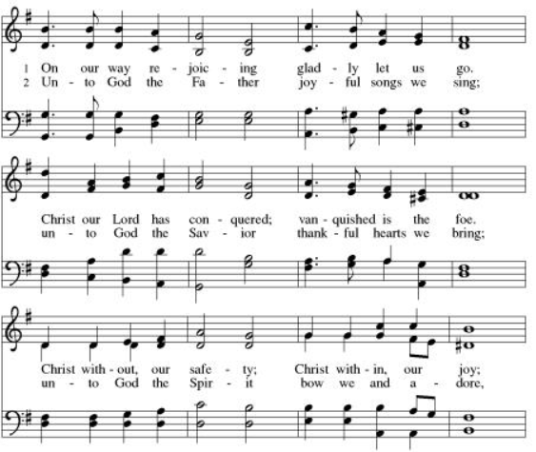
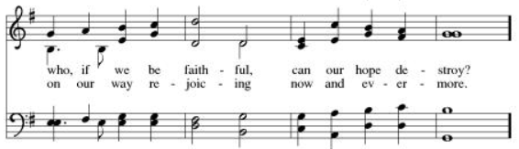
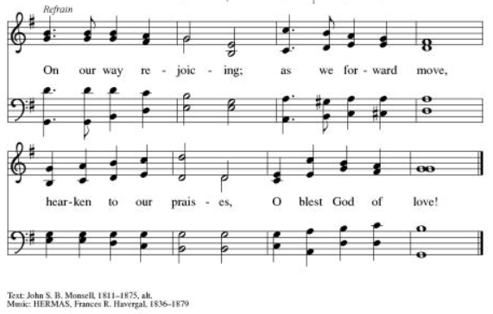

Dismissal
Go in peace. Serve the Lord.
Thanks be to God.

From sundaysandseasons.com.

Copyright © 2020 Augsburg Fortress. All rights reserved.

