Worship at Home: 4/9/2020
Maundy Thursday

GATHERING

CONFESSION AND FORGIVENESS
Friends in Christ, in this Lenten season we have heard our Lord’s call to struggle against sin, death, and the devil—all that keeps us from loving God and each other. This is the struggle to which we were called at baptism. [We have shared this discipline of Lent with new brothers and sisters in Christ who will be baptized at the Easter Vigil.]
Within the community of the church, God never wearies of forgiving sin and giving the peace of reconciliation. On this night let us confess our sin against God and our neighbor, and enter the celebration of the great Three Days reconciled with God and with one another.
Most merciful God,
we confess that we are captive to sin and cannot free ourselves. We have sinned against you in thought, word, and deed, by what we have done and by what we have left undone. We have not loved you with our whole heart; we have not loved our neighbors as ourselves. For the sake of your Son, Jesus Christ, have mercy on us. Forgive us, renew us, and lead us, so that we may delight in your will and walk in your ways, to the glory of your holy name.
Amen.

In the mercy of almighty God, Jesus Christ was given to die for us, and for his sake God forgives us all our sins. As a called and ordained minister of the church of Christ, and by his authority, I therefore declare to you the entire forgiveness of all your sins, in the name of the Father, and of the ☩ Son, and of the Holy Spirit.
Amen.

GREETING
The grace of our Lord Jesus Christ, the love of God,
and the communion of the Holy Spirit be with you all.
And also with you.

PRAYER OF THE DAY
Let us pray.
Holy God, source of all love, on the night of his betrayal, Jesus gave us a new commandment, to love one another as he loves us. Write this commandment in our hearts, and give us the will to serve others as he was the servant of all, your Son, Jesus Christ, our Savior and Lord, who lives and reigns with you and the Holy Spirit, one God, now and forever. Amen.

WORD

FIRST READING: Exodus 12:1-4 [5-10] 11-14
A reading from Exodus.
¹The Lord said to Moses and Aaron in the land of Egypt: ²This month shall mark for you the beginning of months; it shall be the first month of the year for you. ³Tell the whole congregation of Israel that on the tenth of this month they are to take a lamb for each family, a lamb for each household. ⁴If a household is too small for a whole lamb, it shall join its closest neighbor in obtaining one; the lamb shall be divided in proportion to the number of people who eat of it.¹¹This is how you shall eat it: your loins girded, your sandals on your feet, and your staff in your hand; and you shall eat it hurriedly. It is the passover of the Lord. ¹²For I will pass through the land of Egypt that night, and I will strike down every firstborn in the land of Egypt, both human beings and animals; on all the gods of Egypt I will execute judgments: I am the Lord. ¹³The blood shall be a sign for you on the houses where you live: when I see the blood, I will pass over you, and no plague shall destroy you when I strike the land of Egypt.
¹⁴This day shall be a day of remembrance for you. You shall celebrate it as a festival to the Lord; throughout your generations you shall observe it as a perpetual ordinance.

The word of the Lord.
Thanks be to God.

PSALM: Psalm 116:1-2, 12-19
¹I love the Lord, who has | heard my voice,
and listened to my | supplication,
²for the Lord has given | ear to me
whenev- | er I called.
¹²How shall I re- | pay the Lord
for all the good things God has | done for me?
¹³I will lift the cup | of salvation
and call on the name | of the Lord.
¹⁴I will fulfill my vows | to the Lord
in the presence of | all God’s people.
¹⁵Precious in your | sight, O Lord,
is the death | of your servants.
¹⁶O Lord, truly I | am your servant;
I am your servant, the child of your handmaid; you have freed me | from my bonds.
¹⁷I will offer you the sacrifice | of thanksgiving
and call upon the name | of the Lord.
¹⁸I will fulfill my vows | to the Lord
in the presence of | all God’s people,
¹⁹in the courts of | the Lord‘s house,
in the midst of you, | O Jerusalem.

SECOND READING: 1 Corinthians 11:23-26
A reading from 1 Corinthians.
²³For I received from the Lord what I also handed on to you, that the Lord Jesus on the night when he was betrayed took a loaf of bread, ²⁴and when he had given thanks, he broke it and said, “This is my body that is for you. Do this in remembrance of me.” ²⁵In the same way he took the cup also, after supper, saying, “This cup is the new covenant in my blood. Do this, as often as you drink it, in remembrance of me.” ²⁶For as often as you eat this bread and drink the cup, you proclaim the Lord’s death until he comes.

The word of the Lord.
Thanks be to God.

GOSPEL: John 13:1-17, 31b-35

The holy gospel according to John.
Glory to you, O Lord.

¹Now before the festival of the Passover, Jesus knew that his hour had come to depart from this world and go to the Father. Having loved his own who were in the world, he loved them to the end. ²The devil had already put it into the heart of Judas son of Simon Iscariot to betray him. And during supper ³Jesus, knowing that the Father had given all things into his hands, and that he had come from God and was going to God, ⁴got up from the table, took off his outer robe, and tied a towel around himself. ⁵Then he poured water into a basin and began to wash the disciples’ feet and to wipe them with the towel that was tied around him. ⁶He came to Simon Peter, who said to him, “Lord, are you going to wash my feet?” ⁷Jesus answered, “You do not know now what I am doing, but later you will understand.” ⁸Peter said to him, “You will never wash my feet.” Jesus answered, “Unless I wash you, you have no share with me.” ⁹Simon Peter said to him, “Lord, not my feet only but also my hands and my head!” ¹⁰Jesus said to him, “One who has bathed does not need to wash, except for the feet, but is entirely clean. And you are clean, though not all of you.” ¹¹For he knew who was to betray him; for this reason he said, “Not all of you are clean.”
¹²After he had washed their feet, had put on his robe, and had returned to the table, he said to them, “Do you know what I have done to you? ¹³You call me Teacher and Lord—and you are right, for that is what I am. ¹⁴So if I, your Lord and Teacher, have washed your feet, you also ought to wash one another’s feet. ¹⁵For I have set you an example, that you also should do as I have done to you. ¹⁶Very truly, I tell you, servants are not greater than their master, nor are messengers greater than the one who sent them. ¹⁷If you know these things, you are blessed if you do them.”
^{31b}“Now the Son of Man has been glorified, and God has been glorified in him. ³²If God has been glorified in him, God will also glorify him in himself and will glorify him at once. ³³Little children, I am with you only a little longer. You will look for me; and as I said to the Jews so now I say to you, ‘Where I am going, you cannot come.’ ³⁴I give you a new commandment, that you love one another. Just as I have loved you, you also should love one another. ³⁵By this everyone will know that you are my disciples, if you have love for one another.”

The gospel of the Lord.
Praise to you, O Christ.

SERMON

HYMN OF THE DAY Great God, Your Love Has Called Us (ELW 358)

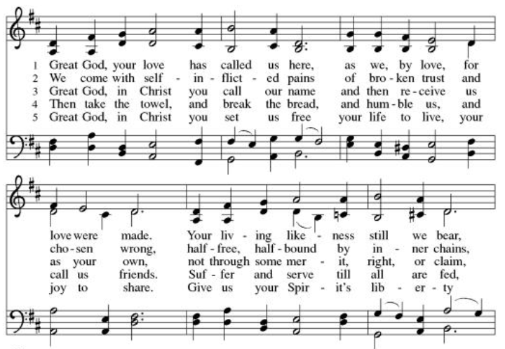
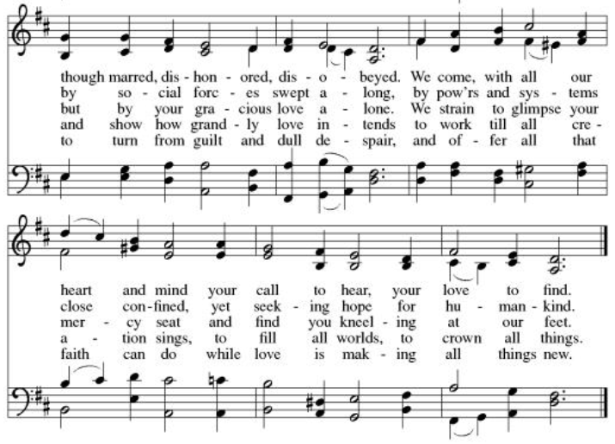

PRAYERS OF INTERCESSION
Turning our hearts to God who is gracious and merciful, we pray for the church, the world, and all who are in need.
For the Family of Willard Wilson – he has passed away at the age of 97 ½ in Port Charlotte FL– former member of PV.
Medical workers; Doctors, Nurses, and Therapists who are working stay healthy
Those who work in service industries providing food and other goods we need.
All in need of healing from the Coronavirus
Deb Friis - cancer treatment - friend of the Vlcek’s
John Smith - healing after another stroke, home again, working on regaining strength in his right hand- friend of the Bahr’s
Bob Timm - healing – legs
Rex Hand – his cancer has returned; friend of the Berger’s
Kim (neighbor to Pr. JonPaul and Jessica) - diagnosed with breast cancer
Riverlyn Walsh – a 2-month-old grandniece of Jennifer and Eric Anderson- has leukemia, is receiving chemo treatments.
Jade Wampole – Granddaughter of Randy and Joann Wampole; has leukemia. She is 4 yrs. old; is responding well to treatments.
Kim Johnson - Sadie's niece - has been diagnosed with lung cancer.
Romaine Knutson – cancer; a member of Pastor’s family
Catherine Erickson – pancreatic cancer
Henry Karnatz – Kari‘s dad- suffering with dementia
Gerri Sessions – strengthening & healing
Holly Poore – in Thailand for 1 year, teaching English
Dan and Shelby Hill and family - missionaries living in France
Keyla Lisbeth - the Sharing the Dream recipient, student in Guatemala
Our service men and women; Alex Bauer stationed in South Korea
The inmates at CVCTF
The neighborhood people we have chosen to pray for this month.

All those on our visiting list:
Bob Dutter, Gary & Sharon Hazen, Jim & Janice Teigen
April Mission offering recipient:
Brad Windjue – an Eleva-Strum teacher diagnosed with esophageal cancer.

According to your steadfast love, O God, hear these and all our prayers as we commend them to you; through Christ our Lord.
Amen.

PEACE
The peace of Christ be with you always.
And also with you.

OFFERING
Please mail your offering to either:

Pleasant Valley Lutheran Church
W2450 Cty Rd WW
Eleva WI 54738.

Roxie Ulness
W3044 Pine Rd.
Eleva WI 54738

LORD’S PRAYER
Gathered into one by the Holy Spirit, let us pray as Jesus taught us.
Our Father, who art in heaven,
hallowed be thy name,
thy kingdom come,
thy will be done,
on earth as it is in heaven.
Give us this day our daily bread;
and forgive us our trespasses,
as we forgive those
who trespass against us;
and lead us not into temptation,
but deliver us from evil.
For thine is the kingdom,
and the power, and the glory,
forever and ever. Amen.

STRIPPING OF THE ALTAR

SOLEMN REPROACHES
O my people, O my church, what have I done to you?
How have I offended you?
Answer me.
I led you out of slavery into freedom,
and delivered you through the waters of rebirth,
but you have prepared a cross for your Savior.
Holy God, holy and mighty, holy and immortal,
have mercy on us.

O my people, O my church, what more could I have done for you?
Answer me.
Forty years I led you through the desert,
feeding you with manna on the way;
I saved you from the time of trial and gave you my body, the bread of heaven,
but you have prepared a cross for your Savior.
Holy God, holy and mighty, holy and immortal,
have mercy on us.

O my people, O my church, what more could I have done for you?
Answer me.
I led you on your way in a pillar of cloud and fire,
but you led me to the judgment hall of Pilate;
I guided you by the light of the Holy Spirit,
but you have prepared a cross for your Savior.
Holy God, holy and mighty, holy and immortal,
have mercy on us.

O my people, O my church, what more could I have done for you?
Answer me.
I planted you as my fairest vineyard, but you brought forth bitter fruit;
I made you branches of the vine and never left your side,
but you have prepared a cross for your Savior.
Holy God, holy and mighty, holy and immortal,
have mercy on us.

O my people, O my church, what more could I have done for you?
Answer me.
I poured out saving water from the rock,
but you gave me vinegar to drink;
I poured out my life and gave you the new covenant in my blood,
but you have prepared a cross for your Savior.
Holy God, holy and mighty, holy and immortal,
have mercy on us.

O my people, O my church, what more could I have done for you?
Answer me.
I gave you a royal scepter, but you gave me a crown of thorns;
I gave you the kingdom and crowned you with eternal life,
but you have prepared a cross for your Savior.
Holy God, holy and mighty, holy and immortal,
have mercy on us.

O my people, O my church, what more could I have done for you?
Answer me.
I struck down your enemies, but you struck my head with a reed;
I gave you my peace, but you draw the sword in my name,
and you have prepared a cross for your Savior.
Holy God, holy and mighty, holy and immortal,
have mercy on us.

O my people, O my church, what more could I have done for you?
Answer me.
I opened the waters to lead you to the promised land,
but you opened my side with a spear;
I washed your feet as a sign of my love,
but you have prepared a cross for your Savior.
Holy God, holy and mighty, holy and immortal,
have mercy on us.

O my people, O my church, what more could I have done for you?
Answer me.
I lifted you up to the heights,
but you lifted me high on a cross;
I raised you from death and prepared for you the tree of life,
but you have prepared a cross for your Savior.
Holy God, holy and mighty, holy and immortal,
have mercy on us.

O my people, O my church, what more could I have done for you?
Answer me.
I grafted you into my people Israel,
but you made them scapegoats for your own guilt,
and you have prepared a cross for your Savior.
Holy God, holy and mighty, holy and immortal,
have mercy on us.

O my people, O my church, what more could I have done for you?
Answer me.
I came to you in the least of your brothers and sisters,
but I was hungry and you gave me no food,
thirsty and you gave me no drink,
a stranger and you did not welcome me,
naked and you did not clothe me,
sick and in prison and you did not visit me,
and you have prepared a cross for your Savior.
Holy God, holy and mighty, holy and immortal,
have mercy on us.

