Worship at Home: 4/12/2020
Easter Sunday

GATHERING
HYMN OF PRAISE Christ Is Risen! Alleluia! (ELW 382)
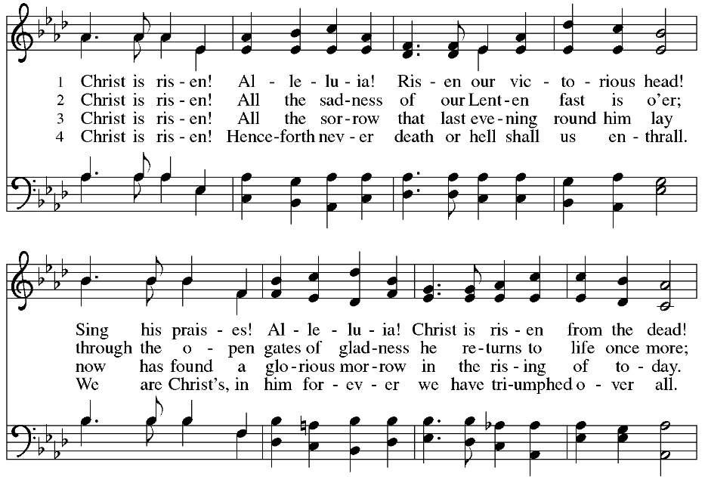
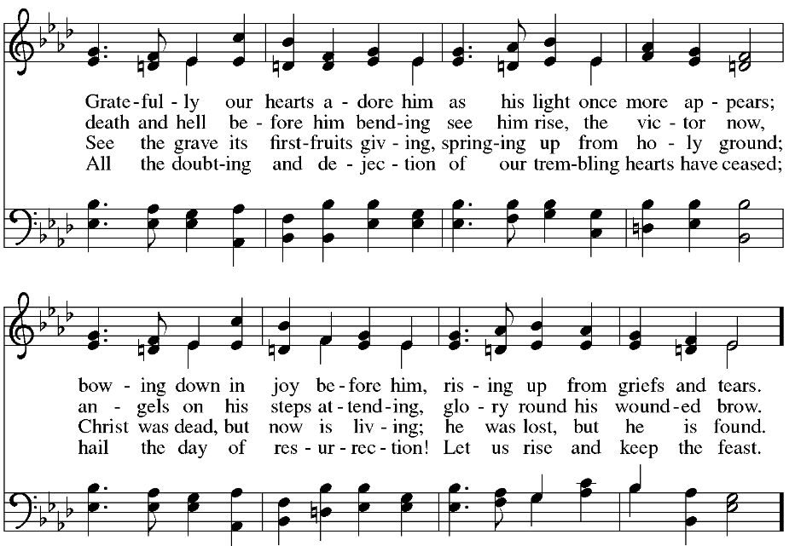

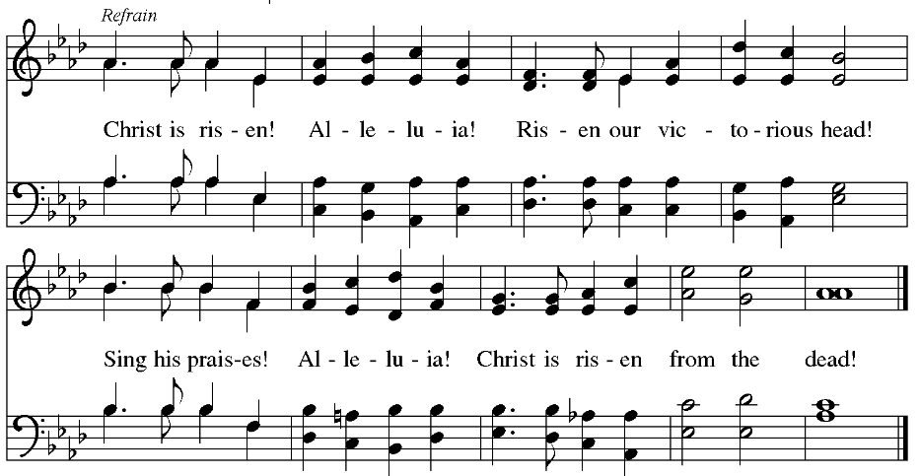

THANKSGIVING FOR BAPTISM
Blessed be the holy Trinity, ☩ one God,
the fountain of living water,
the rock who gave us birth,
our light and our salvation.
Amen.
Joined to Christ in the waters of baptism,
we are clothed with God's mercy and forgiveness.
Let us give thanks for the gift of baptism.
We give you thanks, O God,
for in the beginning your Spirit moved over the waters
and by your Word you created the world,
calling forth life in which you took delight.
Through the waters of the flood you delivered Noah and his family.
Through the sea you led your people Israel from slavery into freedom.
At the river your Son was baptized by John and anointed with the Holy Spirit.
By water and your Word you claim us as daughters and sons,
making us heirs of your promise and servants of all.
We praise you for the gift of water that sustains life,
and above all we praise you for the gift of new life in Jesus Christ.
Shower us with your Spirit,
and renew our lives with your forgiveness, grace, and love.
To you be given honor and praise
through Jesus Christ our Lord
in the unity of the Holy Spirit, now and forever.
Amen.

GATHERING SONG Come, You Faithful, Raise the Strain (ELW 363)
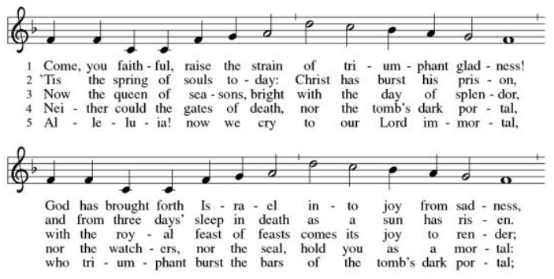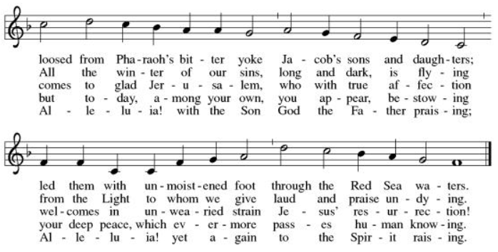

GREETING
The grace of our Lord Jesus Christ, the love of God,
and the communion of the Holy Spirit be with you all.
And also with you.

PRAYER OF THE DAY
Let us pray.
O God, you gave your only Son to suffer death on the cross for our redemption, and by his glorious resurrection you delivered us from the power of death. Make us die every day to sin, that we may live with him forever in the joy of the resurrection, through your Son, Jesus Christ our Lord, who lives and reigns with you and the Holy Spirit, one God, now and forever. Amen.

WORD

FIRST READING: Acts 10:34-43
A reading from Acts.
³⁴Peter began to speak to [the people]: “I truly understand that God shows no partiality, ³⁵but in every nation anyone who fears him and does what is right is acceptable to him. ³⁶You know the message he sent to the people of Israel, preaching peace by Jesus Christ—he is Lord of all. ³⁷That message spread throughout Judea, beginning in Galilee after the baptism that John announced: ³⁸how God anointed Jesus of Nazareth with the Holy Spirit and with power; how he went about doing good and healing all who were oppressed by the devil, for God was with him. ³⁹We are witnesses to all that he did both in Judea and in Jerusalem. They put him to death by hanging him on a tree; ⁴⁰but God raised him on the third day and allowed him to appear, ⁴¹not to all the people but to us who were chosen by God as witnesses, and who ate and drank with him after he rose from the dead. ⁴²He commanded us to preach to the people and to testify that he is the one ordained by God as judge of the living and the dead. ⁴³All the prophets testify about him that everyone who believes in him receives forgiveness of sins through his name.”

The word of the Lord.
Thanks be to God.

PSALM: Psalm 118:1-2, 14-24
¹Give thanks to the Lord, for the | Lord is good;
God’s mercy en- | dures forever.
²Let Israel | now declare,
“God’s mercy en- | dures forever.”
¹⁴The Lord is my strength | and my song,
and has become | my salvation.
¹⁵Shouts of rejoicing and salvation echo in the tents | of the righteous:
“The right hand of the | Lord acts valiantly!
¹⁶The right hand of the Lord| is exalted!
The right hand of the | Lord acts valiantly!”
¹⁷I shall not | die, but live,
and declare the works | of the Lord.
¹⁸The Lord indeed pun- | ished me sorely,
but did not hand me o- | ver to death.
¹⁹Open for me the | gates of righteousness;
I will enter them and give thanks | to the Lord.
²⁰“This is the gate | of the Lord;
here the righ- | teous may enter.”
²¹I give thanks to you, for you have | answered me
and you have become | my salvation.
²²The stone that the build- | ers rejected
has become the chief | cornerstone.
²³By the Lord has | this been done;
it is marvelous | in our eyes.
²⁴This is the day that the | Lord has made;
let us rejoice and be | glad in it.

SECOND READING: Colossians 3:1-4
A reading from Colossians.
¹If you have been raised with Christ, seek the things that are above, where Christ is, seated at the right hand of God. ²Set your minds on things that are above, not on things that are on earth, ³for you have died, and your life is hidden with Christ in God. ⁴When Christ who is your life is revealed, then you also will be revealed with him in glory.

The word of the Lord.
Thanks be to God.

GOSPEL: Matthew 28:1-10
The holy gospel according to Matthew.
Glory to you, O Lord.
¹After the sabbath, as the first day of the week was dawning, Mary Magdalene and the other Mary went to see the tomb. ²And suddenly there was a great earthquake; for an angel of the Lord, descending from heaven, came and rolled back the stone and sat on it. ³His appearance was like lightning, and his clothing white as snow. ⁴For fear of him the guards shook and became like dead men. ⁵But the angel said to the women, “Do not be afraid; I know that you are looking for Jesus who was crucified. ⁶He is not here; for he has been raised, as he said. Come, see the place where he lay. ⁷Then go quickly and tell his disciples, ‘He has been raised from the dead, and indeed he is going ahead of you to Galilee; there you will see him.’ This is my message for you.” ⁸So they left the tomb quickly with fear and great joy, and ran to tell his disciples. ⁹Suddenly Jesus met them and said, “Greetings!” And they came to him, took hold of his feet, and worshiped him. ¹⁰Then Jesus said to them, “Do not be afraid; go and tell my brothers to go to Galilee; there they will see me.”
The gospel of the Lord.
Praise to you, O Christ.

SERMON

HYMN OF THE DAY Jesus Christ Is Risen Today (ELW 365)
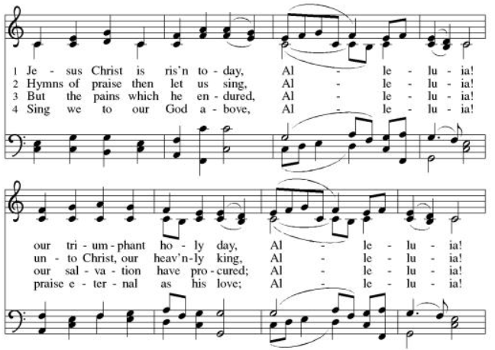
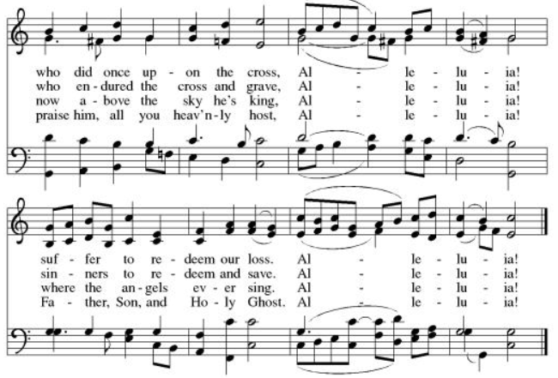

CREED
I believe in God, the Father almighty,
creator of heaven and earth.
I believe in Jesus Christ, God’s only Son, our Lord,
who was conceived by the Holy Spirit,
born of the virgin Mary,
suffered under Pontius Pilate,
was crucified, died, and was buried;
he descended to the dead.*
On the third day he rose again;
he ascended into heaven,
he is seated at the right hand of the Father,
and he will come to judge the living and the dead.
I believe in the Holy Spirit,
the holy catholic church,
the communion of saints,
the forgiveness of sins,
the resurrection of the body,
and the life everlasting. Amen.

PRAYERS OF INTERCESSION

For the Family of Willard Wilson – he has passed away at the age of 97 ½ in Port Charlotte FL– former member of PV.
Medical workers; Doctors, Nurses, and Therapists who are working stay healthy
Those who work in service industries providing food and other goods we need.
All in need of healing from the Coronavirus
Deb Friis - cancer treatment - friend of the Vlcek’s
John Smith - healing after another stroke, home again, working on regaining strength in his right hand- friend of the Bahr’s
Bob Timm - healing – legs
Rex Hand – his cancer has returned; friend of the Berger’s
Kim (neighbor to Pr. JonPaul and Jessica) - diagnosed with breast cancer
Riverlyn Walsh – a 2-month-old grandniece of Jennifer and Eric Anderson- has leukemia, is receiving chemo treatments.
Jade Wampole – Granddaughter of Randy and Joann Wampole; has leukemia. She is 4 yrs. old; is responding well to treatments.
Kim Johnson - Sadie's niece - has been diagnosed with lung cancer.
Romaine Knutson – cancer; a member of Pastor’s family
Catherine Erickson – pancreatic cancer
Henry Karnatz – Kari‘s dad- suffering with dementia
Gerri Sessions – strengthening & healing
Holly Poore – in Thailand for 1 year, teaching English
Dan and Shelby Hill and family - missionaries living in France
Keyla Lisbeth - the Sharing the Dream recipient, student in Guatemala
Our service men and women; Alex Bauer stationed in South Korea
The inmates at CVCTF
The neighborhood people we have chosen to pray for this month.

All those on our visiting list:
Bob Dutter, Gary & Sharon Hazen, Jim & Janice Teigen
April Mission offering recipient:
Brad Windjue – an Eleva-Strum teacher diagnosed with esophageal cancer.

PEACE
The peace of Christ be with you always.
And also with you.

OFFERING
Please mail your offering to either:

Pleasant Valley Lutheran Church
W2450 Cty Rd WW
Eleva WI 54738.

Roxie Ulness
W3044 Pine Rd.
Eleva WI 54738

THANKSGIVING FOR THE WORD
Let us pray.
Praise and thanks to you, holy God, for by your Word you made all things: you spoke light into darkness, called forth beauty from chaos, and brought life into being. For your Word of life, O God,
we give you thanks and praise.
By your Word you called your people Israel to tell of your wonderful gifts: freedom from captivity, water on the desert journey, a pathway home from exile, wisdom for life with you. For your Word of life, O God,
we give you thanks and praise.
Through Jesus, your Word made flesh, you speak to us and call us to witness: forgiveness through the cross, life to those entombed by death, the way of your self-giving love. For your Word of life, O God,
we give you thanks and praise.
Send your Spirit of truth, O God; rekindle your gifts within us: renew our faith, increase our hope, and deepen our love, for the sake of a world in need. Faithful to your Word, O God, draw near to all who call on you; through Jesus Christ, our Savior and Lord, to whom, with you and the Holy Spirit, be honor and glory forever.
Amen.

LORD’S PRAYER
Gathered into one by the Holy Spirit, let us pray as Jesus taught us.
Our Father, who art in heaven,
hallowed be thy name,
thy kingdom come,
thy will be done,
on earth as it is in heaven.
Give us this day our daily bread;
and forgive us our trespasses,
as we forgive those
who trespass against us;
and lead us not into temptation,
but deliver us from evil.
For thine is the kingdom,
and the power, and the glory,
forever and ever. Amen.

SENDING
God blesses us and sends us in mission to the world.

ANNOUNCEMENTS

BLESSING
The Lord bless you and keep you.
The Lord’s face shine on you with grace and mercy.
The Lord look upon you with favor and ☩ give you peace.
Amen.

SENDING SONG Alleluia! Jesus Is Risen! (ELW 377)

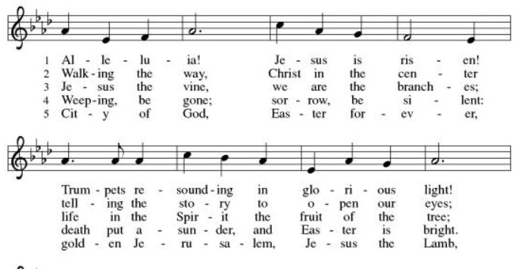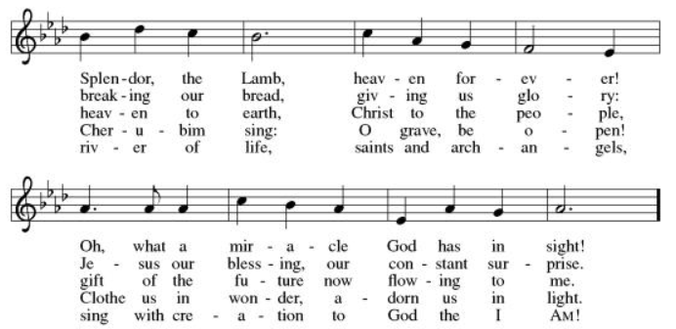

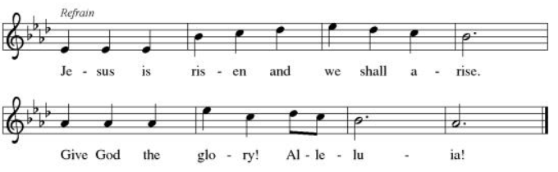

DISMISSAL
Go in peace. Share the good news.
Thanks be to God.

From sundaysandseasons.com.

Copyright © 2020 Augsburg Fortress. All rights reserve

